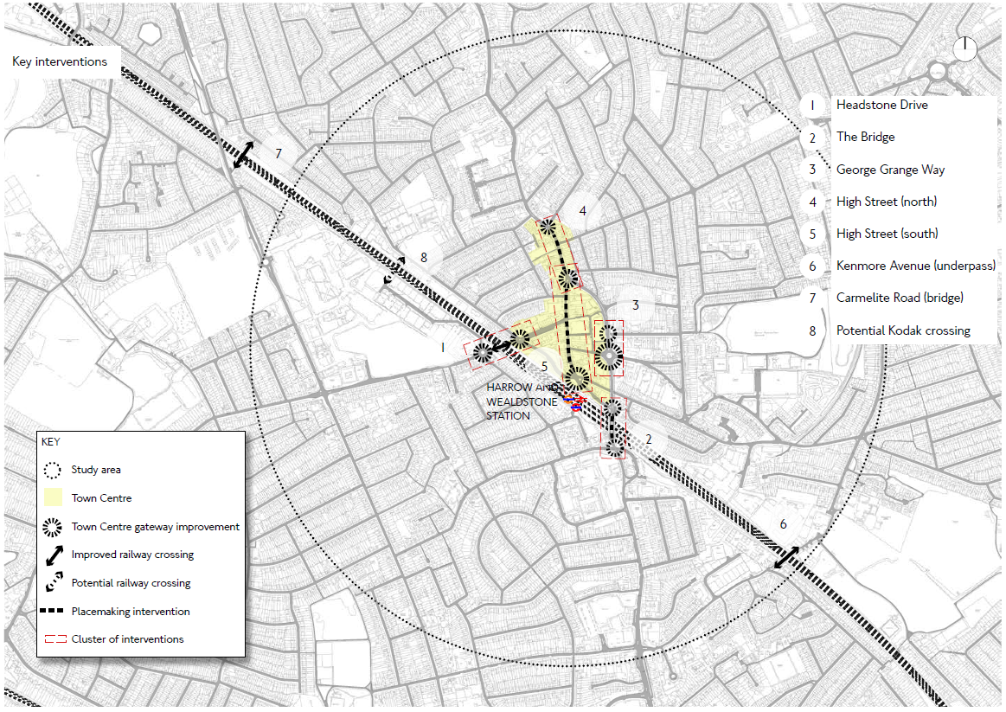

**APPENDIX C – TRAVEL GATEWAYS AND CONNECTIONS**

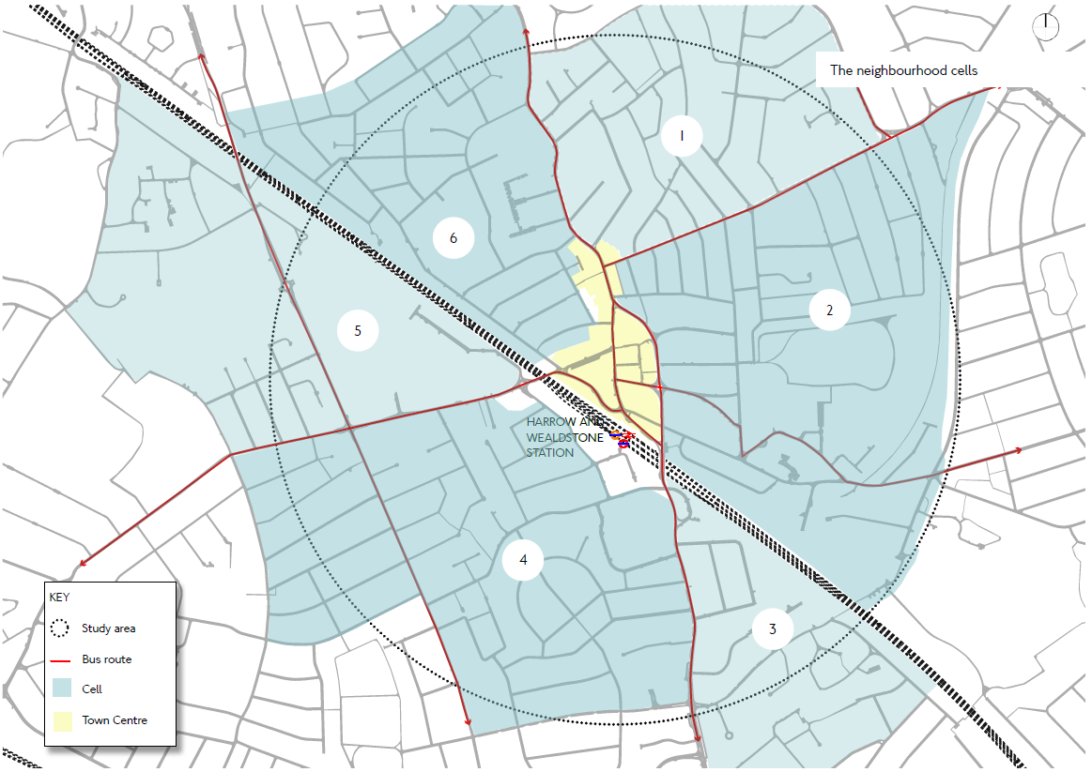

**APPENDIX C – RESIDENTIAL SUB NEIGHBOURHOODS**